UNIVERSITY OF WATERLOO
Software Engineering

Preliminary Robotics Design Report on Calibration, Movement, and Sensors

Professor Billy Bishop, Electrical and Computer Engineering
University of Waterloo
Waterloo, Ontario, N2L 3G1

Prepared by
Team 13
Burstyn, Daniel Maximilian
Eshiokwu, Ikechukwu
Hindson, Douglas
Kendle, James
Liu, Ruich
Phan, Matthew
Sharma, Saumaya
Thai, Lisa
Xie, Karen Jie Ru
1A Software Engineering
Nov, 9, 2006
November 9, 2006

Dr. W. D. Bishop
SE 101 Course Instructor
University of Waterloo
Waterloo, ON N2L 3G1

Dear Prof. William David Bishop:

The report attached is entitled “Preliminary Robotics Design Report on Calibration, Movement, and Sensors” and it is based on our 1A software engineering project. The project is to program a LEGO® Robot to follow through a maze. The software that is going to be used is leJOS and the program should be built as an event-driven program.

Our project team name is “13-37” and we consist of two main groups: coders and writers. In brief description, the coders are broken down into two categories: motion and calibration. The writers are to work on the preliminary report, record the team’s progress on the project, and write the final report.

The preliminary design report will consist of a Gantt chart, introduction of the project, and a summary of design teams. The Gantt chart will describe the timeline and progression of our project. Since this is not a final report, there will not be any technical details or any information from the engineering perspective.

We, as a team received no external help in writing this report. We also confirm that this report has not been previously submitted for an academic credit at this or any other academic institution.

Sincerely,
Team 13-37
i
Table of Contents

Letter of Submittal i
Table of Contents ii
List of Figures...............................................................................................................iii

Introduction. 1
Team Description 3
References 5

ii
List of Figures

Figure 1: Gantt Chart of Project Timeline 4

iii
Introduction
This fall 2006 term, Team 13-37 aims to program a LEGO® robot that will run through a designated course. We also want to be the fastest out of twelve other groups who will be completing the same course. We will accomplish this by using a LEGO® operating system called leJOS to maneuver the robot based on the sensor readings. Additionally, by breaking up our team into smaller groups, recognizing what the programmers need to accomplish, and frequently communicating with other members, we expect a great outcome for this project.
In order to maintain productivity, our team has been split into two subgroups: programming and technical writing. Each member is assigned to a group and is given a specific task based on their strengths and weaknesses. Therefore, we are able to maximize our efficiency by allowing those knowledgeable in programming to focus only on that aspect and not on the technical writing, and vice versa. This will allow us to not only have the robot finished in time, but also to perform further testing of the robot and the proof reading of the technical documents.
Specifically, the programming subgroup recognizes several issues that are to be resolved before any progress can be made. These include the compilation of leJOS onto several personal laptops, understanding how to use the RCX brick and creating a version control system. The latter would allow our group to perform simultaneous development on source code files, archive differences in source code files to allow restoration of a previous version, and track changes to source code. Also, this permits our programmers to work on the same code file simultaneously in an organized fashion.
However, the main challenge for the programming subgroup is the coding of the LEGO® robot itself. The group must agree on the design of and build a Java program that will consider sensor placement and a turning method for the robot. This will be accomplished through brainstorming, brainwriting and compromise of disagreements.

1
There are many details included in this design report. An example is the summary of the design teams. The summary includes a description of the team members and the tasks that they are expected to complete. In addition, the Gantt chart is a very important part of this report, which shows the timeline of our project. It describes how long each segment of the project will take to complete. Furthermore, it allows us to see if everything is going according to schedule. If it is not, then we can try to resolve the cause(s) of the delay. Without the chart, the entire project would be more difficult to complete because we would not know which parts should be complete during any given time. Finally, the references section of this report lists, using the MLA format, the resources that we used to complete this design report and the code that makes the robot move.
In conclusion, strong communication between team members plays a key role in the success of our team. In order to eliminate procrastination, we hold meetings every Tuesday morning in order to discuss any problems, solutions or improvements that we have come across. Furthermore, we have created a Gantt chart which divides our project into a series of smaller tasks. This will let us know exactly what tasks need to be accomplished and when they should be completed.

2

Team Description

Our team consists of nine students, and they are: Daniel Max Burstyn, Ikechukwu Eshiokwu, Douglas Hindson, James Kendle, Ruichi Lui, Matthew Phan, Saumaya Sharma, Lisa Thai, and Karen Xie. Arranging meetings outside of class will be fairly challenging, so we have decided to split the team into two sub-teams. This makes it much easier to arrange sub-team meetings, and it also gives everyone a designated task to complete. The first sub-team is dedicated to writing the project deliverables and it consists of Ruichi, Matthew, Saumaya, Lisa and Karen. The second sub-team consists of four people, who are responsible to program and test the robot. This team is made up of Max, Ikechukwu, Douglas and James.

The members on the technical writing team work on the documents that are to be submitted. These members also take notes during each meeting, which describe possible problems that were encountered and how they were resolved. They also record the results from testing the robot and any new ideas that arise from the testing. These notes will also be used in the final report. Each person on the technical writing team has a designated task for each project deliverable. These tasks are based on the required components for the reports and each person’s skills.

The coding team is further separated into two teams, having two members each. The first team is dedicated to programming the calibration of the sensors. This sub-team consists of Ikechukwu and James. The second team is dedicated to programming the robot to move using the sensor readings. This sub-team consists of Max and Douglas. The majority of the robot testing will be done by the coding team because they are the ones who will have the best understanding of the programming.

Although the team is split in two for each type of task, all team members participate in discussions concerning the general robot design. Some discussion topics include: whether the robot will move forward or backwards; the speed that the robot will move at; how the robot will turn, etc.

3
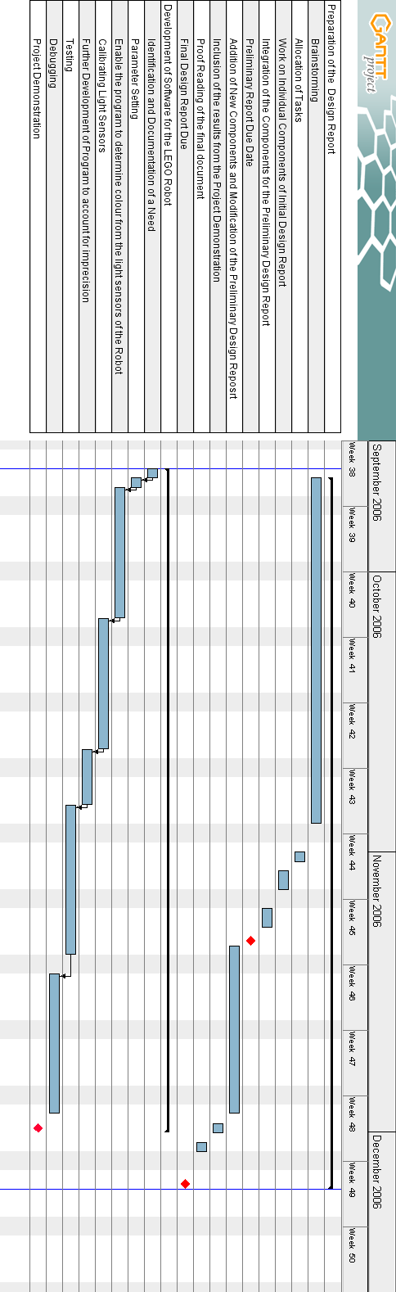
4

References

Scholz, Matthias Paul , Brian Bagnall, and Lawrie Griffiths. Lejos Tutuorial: A practical
guide for developers.
2 Nov. 2006 <http://lejos.sourceforge.net/tutorial/>

GanttProject. Vers. 2.0.2 . Online.
3 Nov 2006. <http://ganttproject.sourceforge.net/>

USB Tower Driver Vers. 1.64 . Online.
11 Oct 2006 <http://www.lego.com/eng/education/mindstorms/home.asp?pagename=download>

5

